Starting at $2,832.05 per couple
January Dates & $400 Deposit

- Exclusive Nonstop Vacation Flights from Kansas City, St. Louis, Pittsburg, and many other cities.
- Transportation
- All-inclusive resort

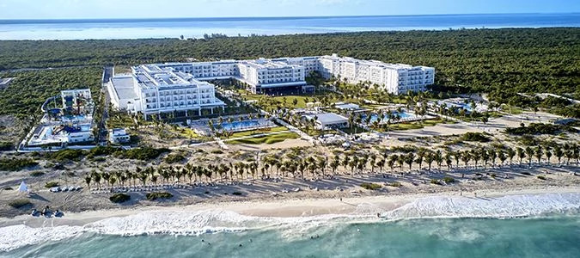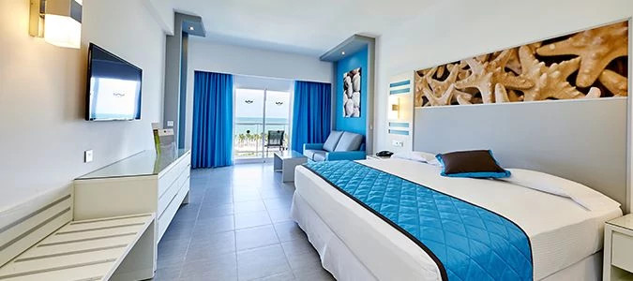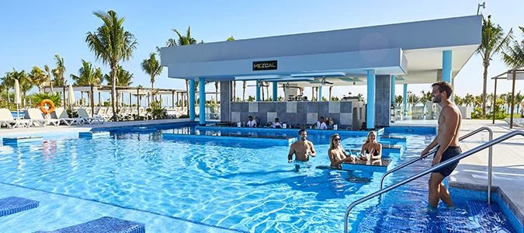

If you are interested, please kindly email me with the following for both passengers:
- First, Middle, Last Name as it appears on your passport
- Your email address & phone number
- If you do not have a 2nd passenger, the single supplement is $400

***Cashback Cancel Anytime insurance is required at the time of booking. This is a separate charge of $150 per person and can vary by age/state.***

